**Bore Pump Control**

**Requirement Model**

**Change log**

This table lists the changes since LCOM.

|  |  |  |
| --- | --- | --- |
| Date | Author | Notes |
| 05/06/2020 | Andrew | Added controller restart log use case |
| 06/06/2020 | Andrew | Added status change report use case |
| 06/06/2020 | Andrew | Added fill time estimate use case |
| 14/06/2020 | Andrew | Added Use Case to describe the controller ignoring invalid messages |
| 15/06/2020 | Andrew | Updated use case diagram to include new use cases |
| 15/06/2020 | Tristan | Added new state and sequence diagrams |
| 15/06/2020 | David | Added updated data flow diagram |
| 15/06/2020 | David | Updated NFR’s to more accurately reflect the project |
| 15/06/2020 | Andrew | Collected new diagrams and updates to the doc. Added title page and change log |
| 18/08/2020 | David | Added use case for stopping pump when an error input signal is asserted |
| 11/09/2020 | David | Updated some use-cases, removed others that ended up not being part of the system. |

# Bore Pump Control Requirement Model

# Use-Cases:

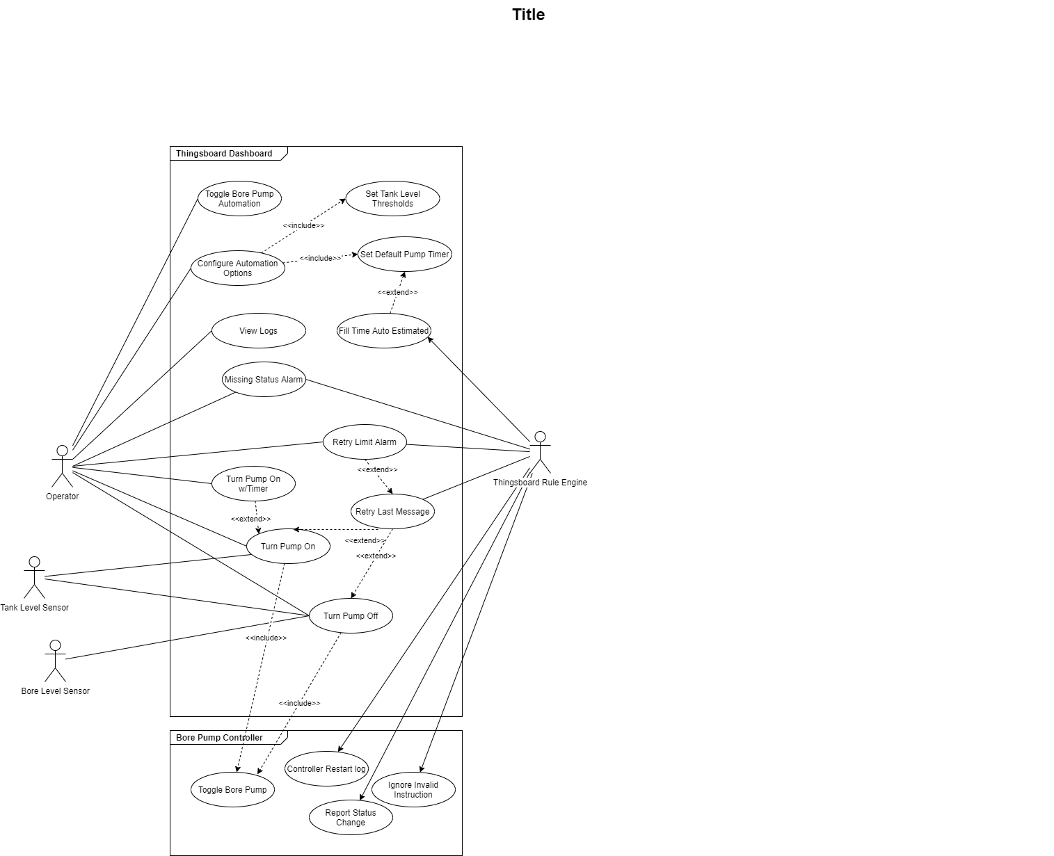

# Use-Case: Manually Turn On The Pump

1. Brief Description

When operator wants to turn the pump on, they press the manual pump toggle to on so that a message will be sent to the pump to be turned on and given the default timer.

1. Actors
   1. Operator

Operator is the person using the bore pump control. Primarily this represents the farm manager at DPI, although there may be other users.

1. Pre-Conditions
   1. Operator is logged into Thingsboard and is on the Bore Pump Dashboard.
   2. Bore pump is in off state.
2. Normal Flow

|  |  |
| --- | --- |
| Actor | System |
| 1. Operator presses the button to turn the pump on. |  |
|  | 2. Prepares and sends an instruction message to the pump controller telling it to turn on with a default timer. |
|  | 3. Instruction message is sent to ThingsNetwork and is held until the pumps next status message. |
|  | 4. Pump sends status message to Thingsboard at its normal interval. |
|  | 5. ThingsNetwork receives status message, and immediately sends instruction message while the pump can receive. |
|  | 6. Borepump receive instruction message and actions it. |
|  | 7. A new status message is sent to ThingsNetwork from the bore pump, with its new status. |
|  | 8. ThingsNetwork forwards the message to Thingsboard and the Dashboard is updated. |

The use case ends.

1. Alternate Flows
   1. Instruction Message Is Lost

If at step 3 of the normal flow if the pump does not receive the instruction message then

|  |  |
| --- | --- |
| Actor | System |
|  | 4.Pump sends status message to Thingsboard at its normal interval. Status message indicates the pump is off |
|  | 5.Thingsboard receives the status message and determines that the pump is still off. Last instruction message is resent |
|  | 6.Normal process resumes at step 2. |

1. Post-conditions
   1. Bore pump is on and pumping with the default timer.
   2. Thingsboard dashboard indicates that the pump is on.
   3. Thingsboard has a log of the pump being turned on.

# Use-Case: Manually Turn On the Bore Pump with Timer

1. Brief Description

When the operator wants to turn the pump on with a timer, they select either a custom duration they can enter or they elect to use the estimated fill time, and press the manual pump toggle to on so that a message will be sent to the pump to turn on for the duration of the timer.

1. Actors
   1. Operator

Operator is the person using the bore pump control. Primarily this represents the farm manager at DPI, although there may be other users.

1. Pre-Conditions
   1. Operator is logged into Thingsboard and is on the Bore Pump Dashboard.
   2. Bore pump is in off state.
2. Normal Flow

|  |  |
| --- | --- |
| Actor | System |
| 1. Operator selects “Custom Timer” and enters the specified pump duration into the custom timer field. |  |
| 2. Operator presses the button to turn the pump on. |  |
|  | 3.Prepares and sends an instruction message to the pump controller telling it to turn on with specified timer. |
|  | 4. Instruction message is sent to ThingsNetwork and is held until the pumps next status message. |
|  | 5. ThingsNetwork receives status message, and immediately sends instruction message while the pump can receive. |
|  | 6. Borepump receive instruction message and actions it. |
|  | 7. A new status message is sent to ThingsNetwork from the bore pump, with its new status. |
|  | 8.ThingsNetwork forwards the message to Thingsboard and the Dashboard is updated. |

The use case ends.

1. Alternate Flows
   1. Use the estimated fill timer  
      At step 1 the user may elect to use the estimated fill time instead of entering a custom duration.

|  |  |
| --- | --- |
| Actor | System |
| 1. Operator selects “Estimate Fill Timer”. |  |
| 2. Operator presses the button to turn the pump on. |  |
|  | Normal process resumes at step 3. |

* 1. Instruction message is lost

If at step 3 of the normal flow the if pump does not receive the instruction message then

|  |  |
| --- | --- |
| Actor | System |
|  | 4.Pump sends status message to Thingsboard at its normal interval. Status message indicates the pump is off |
|  | 5.Thingsboard receives the status message and determines that the pump is still off. Last instruction message is resent |
|  | 6.Normal process resumes at step 2. |

1. Post-conditions
   1. Pump is turned on and is pumping.
   2. Pump is set to turn off after timer.
   3. Dashboard shows pump is turned on.
   4. Dashboard shows timer countdown.
   5. Thingsboard has a log of the pump being turned on.

# Use-Case: Manually Turn Off the Bore Pump

1. Brief Description

When operator wants to turn the pump off, they press the manual pump toggle to off so that a message will be sent to the pump to be turned off and any timers will be cleared.

1. Actors
   1. Operator

Operator is the person using the bore pump control. Primarily this represents the farm manager at DPI, although there may be other users.

1. Pre-Conditions
   1. Operator is logged into Thingsboard and is on the Bore Pump Dashboard.
   2. Bore pump is in on state.
2. Normal Flow

|  |  |
| --- | --- |
| Actor | System |
| 1. Operator presses the button to turn the pump off |  |
|  | 2.The Dashboard send instruction message to the pump, telling it to turn off. |
|  | 3. Instruction message is sent to ThingsNetwork and is held until the pumps next status message. |
|  | 4. Pump sends status message to Thingsboard at its normal interval. |
|  | 5. ThingsNetwork receives status message, and immediately sends instruction message while the pump can receive. |
|  | 6. Borepump receive instruction message and actions it. |
|  | 7. A new status message is sent to ThingsNetwork from the bore pump, with its new status. |
|  | 8.ThingsNetwork forwards the message to Thingsboard and the Dashboard is updated. |

The use case ends.

1. Alternate Flows
   1. Instruction Message Is Lost

If at step 3 of the normal flow if the pump does not receive the instruction message then

|  |  |
| --- | --- |
| Actor | System |
|  | 4.Pump sends status message to Thingsboard at its normal interval. Status message indicates the pump is on |
|  | 5.Thingsboard receives the status message and determines that the pump is still on. Last instruction message is resent |
|  | 6.Normal process resumes at step 2. |

1. Post-conditions
   1. Bore pump is off.
   2. Thingsboard dashboard indicates that the pump is off.
   3. Thingsboard has a log of the pump being turned off.

# Use-Case: Toggle Bore Pump Automation

1. Brief Description

When operator wants to toggle the automated control of the bore pump, in response to tank level sensor readings, they press the bore pump automation toggle. This starts or stops Thingsboard automatically sending instruction messages to the pump in response to the tank level.

1. Actors
   1. Operator

Operator is the person using the bore pump control. Primarily this represents the farm manager at DPI, although there may be other users.

1. Pre-Conditions
   1. Operator is logged into Thingsboard and is on the Bore Pump Dashboard.
2. Normal Flow

|  |  |
| --- | --- |
| Actor | System |
| 1. Operator presses the button to turn pump automation on |  |
|  | 2.The dashboard sets the toggle to show automation is turned on |
|  | 3.Tank level information is received from the bore pump at regular intervals |
|  | 4.Dashboard initiates turn on/off the pump base don the tank level information |

The use case ends.

1. Alternate Flows
   1. Turn off automation

If at step 1 of the normal flow if automation is currently on

|  |  |
| --- | --- |
| Actor | System |
| 1. Operator presses the button to turn pump automation off |  |
|  | 2.The dashboard sets the toggle to show automation is turned off |
|  | 3.Tank level information is received from the bore pump at regular intervals |
|  | 4.Dashboard logs tank levels but does not act on them. |

1. Post-conditions
   1. Bore pump is toggled.

# Use-Case: Tank level sensor turns pump on/off

1. Brief Description

When the tank level drops below a set value, the system sends a turn on message to the bore pump so that the bore pump will turn on and fill the tank.

1. Actors
   1. Tank Level Sensor

The tank level sensor detects and reports the level of water in the tank that the bore pump fills

1. Pre-Conditions
   1. Bore pump automation is on.
2. Normal Flow

|  |  |
| --- | --- |
| Actor | System |
| 1. Tank level sensor information is received by Thingsboard. |  |
|  | 2.Thingsboard checks the tank level against minimum and maximum levels. |
|  | 3.The tank level is below minimum level. |
|  | 4.Thingsboard sends instruction message to the bore pump controller to turn pump on. |
|  | 5.Pump controller receives instruction message and turns pump on, sends status message. |

The use case ends.

1. Alternate Flows
   1. Tank is above maximum level

If at step 3 of the normal flow if the level is above maximum level.

|  |  |
| --- | --- |
| Actor | System |
|  | 4. Thingsboard sends instruction message to the bore pump controller to turn pump off. |
|  | 5. Pump controller receives instruction message and turns pump off, sends status message. |

1. Post-conditions
   1. Bore pump is on/off depending on reported tank level.
   2. Thingsboard dashboard indicates pump status

# Use-Case: Configure Automation Levels

1. Brief Description

Configure the low and high tank level thresholds for automatic control.

1. Actors
   1. Operator

Operator is the person using the bore pump control. Primarily this represents the farm manager at DPI, although there may be other users.

1. Pre-Conditions
   1. Operator is logged into Thingsboard and is on the Bore Pump Dashboard.
2. Normal Flow

|  |  |
| --- | --- |
| Actor | System |
| 1. Operator changes the low level threshold value. | The value is saved. |
| 2. Operator changes the high level threshold value. | The value is saved. |

The use case ends.







1. Post-conditions
   1. The modified values have been saved.







# Use-Case: Downlink command lost

1. Brief Description

If, after sending a command to the pump controller, the expected state change is not reported within two status messages the dashboard shall inform the operator of the problem.

1. Actors
   1. Dashboard

The dashboard interprets the status messages from the pump and displays the current state of the system.

* 1. Operator

Operator is the person using the bore pump control. Primarily this represents the farm manager at DPI, although there may be other users.

1. Pre-Conditions
   1. The dashboard and pump controller can communicate.
2. Normal Flow

|  |  |
| --- | --- |
| Actor | System |
| The operator sends a command to the pump controller, eg switch on the pump. | The command is scheduled for delivery after the next status message. |
|  | A status message arrives but does not match expected status. This is expected because the command has not been delivered yet. |
|  | The command is not received by the pump controller. |
|  | The pump controller sends the next scheduled status message with no change in state because it did not receive the command. |
|  | The dashboard indicates the command was lost. |

The use case ends.

1. Post-conditions
   1. The dashboard indicates that pump is unresponsive.

# Use-Case: Raise alarm for missing status message

1. Brief Description

Status messages are received from the pump at regular intervals. When two messages are missed in a row the system raises an alarm so that operator can respond.

1. Actors
   1. Bore pump control system

The bore pump control system interprets the status messages from the pump and responds

* 1. Operator

Operator is the person using the bore pump control. Primarily this represents the farm manager at DPI, although there may be other users.

1. Pre-Conditions
   1. One status message has been missed
2. Normal Flow

|  |  |
| --- | --- |
| Actor | System |
|  | 1. System detects a second status message has been missed. |
|  | 2.Alarm is raised to the dashboard. |
| 3. Operator gets alarm and tends to issue. |  |
|  | 4.Alarm cleared when new status message received. |

The use case ends.

1. Alternate Flows

N/A

1. Post-conditions
   1. Pump controller is sending messages that are received by the dashboard.

# Use-Case: Pump controller reports sensor status change

1. Brief Description

Whenever the pump controller reads a change in its sensors it sends a new status message to Thingsboard outside of the normal status cycle

1. Actors
   1. Bore pump control system

The bore pump control system interprets the status messages from the pump and responds

1. Pre-Conditions
   1. Bore Pump has had the status of a pin change
2. Normal Flow

|  |  |
| --- | --- |
| Actor | System |
|  | 1. System detects that the status of a pin has changed |
|  | 2.Status Message is sent to Dashboard |
|  | 3.Dashboard updates it’s status to reflect pin change. |

The use case ends.

1. Alternate Flows

N/A

1. Post-conditions
   1. Dashboard is up to date with the latest status message of the bore pump

# Use-Case: Dashboard automatically estimates the time it will take to fill the tank

1. Brief Description

The default timer of the system will be set to the best estimate of how long the tank will take to fill based on the last status of the tank level sensor.

1. Actors
   1. Bore pump control system

The bore pump control system interprets the status messages from the pump and responds

* 1. Operator

Operator is the person using the bore pump control. Primarily this represents the farm manager at DPI, although there may be other users.

1. Pre-Conditions
   1. User has initiated the tank start filling with a timer set, or the system has automatically determined the tank needs to start filling
2. Normal Flow

|  |  |
| --- | --- |
| Actor | System |
|  | 1.System get’s instruction to start bore pump with a timer |
|  | 2.Last level of the tank, and the average fill time are used to determine how long the tank will take to fill. |
|  | 3.System sends instruction message with the determined timer. |

The use case ends.

1. Alternate Flows

N/A

1. Post-conditions

Bore pump has fill instruction with the determined timer.

# Use-Case: Bore pump controller restarting logs to dashboard

1. Brief Description

When the pump controller has been restarted (likely due to power loss to bore pump) an extra flag is sent in the next status message to log to the dashboard

1. Actors
   1. Bore pump control system

The bore pump control system interprets the status messages from the pump and responds

1. Pre-Conditions
   1. The Bore pump controller has been power cycled.
2. Normal Flow

|  |  |
| --- | --- |
| Actor | System |
|  | 1. Bore pump controller detects that it is restarted. |
|  | 2. Status message pump restart flag is set for next status message. Message is sent to thingsboard. |
|  | 3.The dashboard logs that the pump controller has been restarted. |

The use case ends.

1. Alternate Flows

N/A

1. Post-conditions

Thingsboard has a log of when the pump controller has restarted.

# Use-Case: Pump controller will not start pump if any input alarm line is asserted

1. Brief Description

When the Bore Pump receives an instruction message it checks to see if the current status of the pump would prevent turning on. If so the message is ignored

1. Actors
   1. Bore pump control system

The bore pump control system interprets the status messages from the pump and responds

1. Pre-Conditions
   1. The Bore pump controller in on and has a status that would prevent the pump being turned on (e.g. low bore level).
2. Normal Flow

|  |  |
| --- | --- |
| Actor | System |
|  | 1. Bore pump controller receives an instruction message to turn on the pump |
|  | 2. Bore pump controller checks the current status of the pump. |
|  | 3.The pump status would prevent the pump being turned on. |
|  | 4.Instruction is ignored, next status message sent indicating no change. |

The use case ends.

# Use-Case: Pump controller switches pump off due to reported problem

1. Brief Description

If the pump controller detects one of the input alarm signals is raised while the pump is running it switches off the pump and sends a status message to the dashboard.

1. Actors
   1. Pump controller

The pump controller interprets the status messages from the pump and responds

1. Pre-Conditions
   1. The Bore pump controller in on.
   2. The pump is running.
2. Normal Flow

|  |  |
| --- | --- |
| Actor | System |
|  | 1. Pump controller detects one of the input alarm signals has been asserted by the pump, eg low bore level, high pressure, etc. |
|  | 2. Pump controller tells the pump to stop via the output control signal. |
|  | 3. Pump controller sends a status message with the pump running flag false and the appropriate alarm flag true. |
|  | 4. The dashboard raises an alarm and shows the change in pump status. |

The use case ends.

1. Alternate Flows

N/A

1. Post-conditions

Pump is now off, Thingsboard knows new status of the pump.

# Data Model:

Data Flow Diagram:

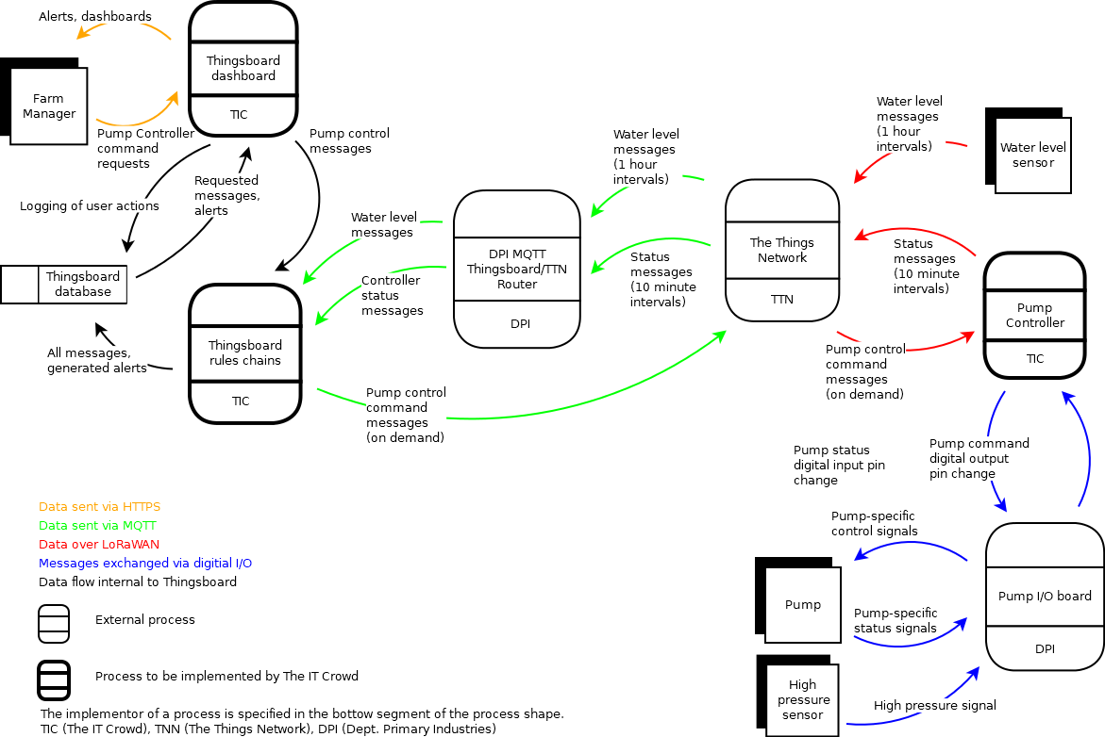

System Diagram: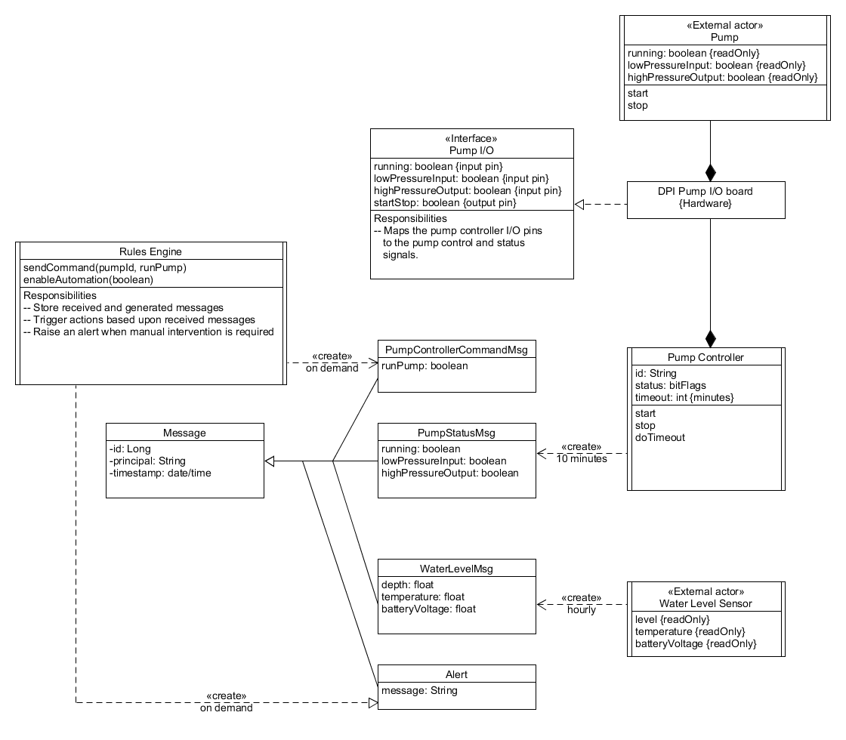

State Diagram:

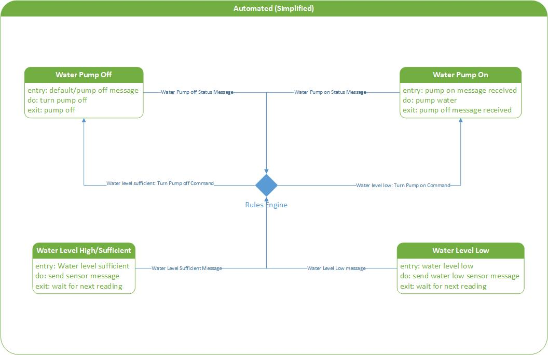

Sequence Diagram: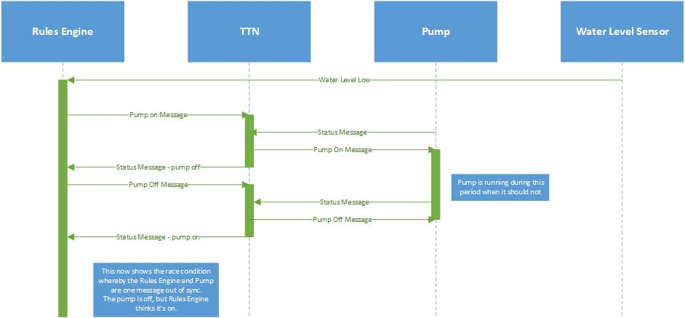

# Non-Functional Requirements:

## Security

BPNFR-001 – The system should enforce user authentication at each entry point.

BPNFR-002 - The system should enforce password requirements.

BPNFR-003 - The system should enforce Communications layer security ie: no unauthorised devices permitted to send or receive messages or replay messages.

**Note: All security NFRs are outside the scope of The IT Crowd’s implementation. The Thingsboard server is hosted and configured by DPI, including user authentication and authorisation and HTTP security. The MQTT channels between Thingsboard and the Things Network are controlled by DPI and/or The Things Network. LoRaWAN RF security is defined in the LoRaWAN standard.**

## Capacity

BPNFR-004 – The system should support one bore pump. (Expansion to be scoped at a later date in consultation with project sponsor).

BPNFR-005 – The system should support a number of simultaneous users to be determined by project sponsor (expect no more than 2).

**Note: Capacity is mainly a factor of ThingsBoard, The Things Network, and LoRaWAN network.**

**Note: Specific message capacity already established as a functional constraint in architecture.**

## Recovery

BPNFR-006 – The Pump Controller will be able start working without intervention in the event of a reset due to power loss, LoRaWAN connectivity loss, etc.

## Compatibility

BPNFR-007 – The system web interface/dashboards/monitoring should be usable on regular PCs/laptops and mobile devices.

## Maintainability

BPNFR-008 – The system documentation of patterns/standards/etc should be sufficient for handover to project sponsor/future users.

## Regulatory

BPNFR-009 – The RF aspects of the system should conform to national RF regulations and the LoRaWAN specification, and The Things Network fair use policy.

## Documentation

BPNFR-010 – All project risks should be documented and analysed in the Risk Register.

BPNFR-011 – All system operations should be documented in How-To documentation.

BPNFR-012 – All relevant system and project documentation should be included in Handover Documentation.